**ENGR 340-Introduction to Environmental engineering**

To: Deborah Sills

From: Loujin Daher

Date: September 17, 2013

Re: Nonlinear Curve Fitting

**Objective:**

The objective of this laboratory analysis is to choose the most appropriate model for a plot of soption isotherm of chlordane on Granulated Activated Carbon. Mass of adsorbate per mass of adsorbent against the concentration of adsorbate will be plotted and based the two equations: q = KC and q = KC1/2 the best model wil be chosen.

Where :

q = mass of adsorbate adsorbed per mass of adsorbent at equilibrium (mg=g),

C = concentration of adsorbate in the aqueous phase at equilibrium (mg=L),

K = Freundlich isotherm soil-water partition coe_cient((mg=g)(L=mg)), and

1/n = Freundlich isotherm intensity parameter (unitless).

**Method:**

The Mass of adsorbate per mass of adsorbent values and the concentration of adsorbate values were already given. Kalliegraph software was then used to plot the data values. The linear equation q = KC was tested first and then Freundlich equation q = KC1/2 was tested as well.

The graphs are shown in Figure 1 and Figure 2. The values of K, which is the reaction rate coefficient, was found using kalliegraph.

**Results and Discussion:**

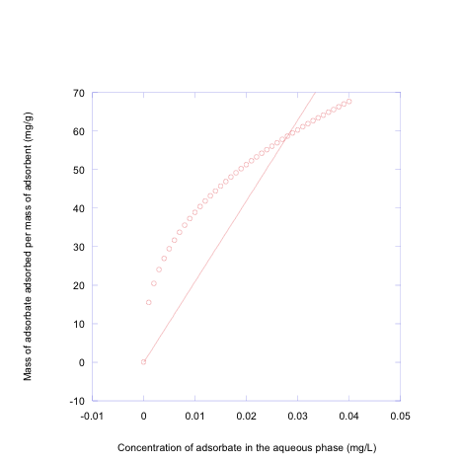

**Figure 1.** For Linear equation: q = KC 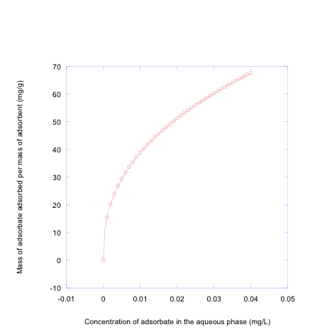

**Figure 2.** q=KC1/n. k=245 and n=2.5

Based on the Kalliegraoh graphs, it was concluded that Freundlich model fits the data values of the mass of adsorbate per mass of adsorbent and the concentration of adsorbate better than the linear equation.